Kyoto Encyclopedia of Genes and Genomes (KEGG)
Biological processes are controlled by many interacting genes, proteins, enzymes, metabolites, and environmental factors. To understand these processes, scientists often use pathway databases such as KEGG.
KEGG stands for Kyoto Encyclopedia of Genes and Genomes. It organizes biological information into pathway maps that show how molecules interact inside cells.
In this module, you will learn how to read a simplified KEGG-style pathway and use biological data to explain observable traits, or phenotypes.

Learning Objectives
After completing this module, you should be able to:
- Interpret a simplified KEGG-style pathway diagram.
- Identify substrates, enzymes, products, and biological outputs.
- Explain how genes, proteins, enzymes, and metabolites are connected.
- Interpret gene-expression, enzyme-activity, metabolite, and phenotype data.
- Predict biological outcomes when a pathway is activated, inhibited, or disrupted.
- Explain why gene expression alone does not always predict the final phenotype.

The KEGG database, or Kyoto Encyclopedia of Genes and Genomes, was established by the Kanehisa Laboratory in 1995. Since then, it has grown into a comprehensive biological information resource that organizes data into four broad categories: systems information, genomic information, chemical information, and health information. These categories are further divided into 15 major databases, with KEGG PATHWAY and KEGG ORTHOLOGY considered among the most central components.

KEGG PATHWAY is one of the most widely used databases within KEGG. It contains pathway maps that are manually curated and drawn by researchers based on published scientific literature. These pathway maps help users understand biological processes, molecular interactions, and functional relationships among genes, enzymes, metabolites, and diseases. KEGG PATHWAY is organized into six main groups: Cellular Processes, Environmental Information Processing, Genetic Information Processing, Human Diseases, Metabolism, and Organismal Systems.

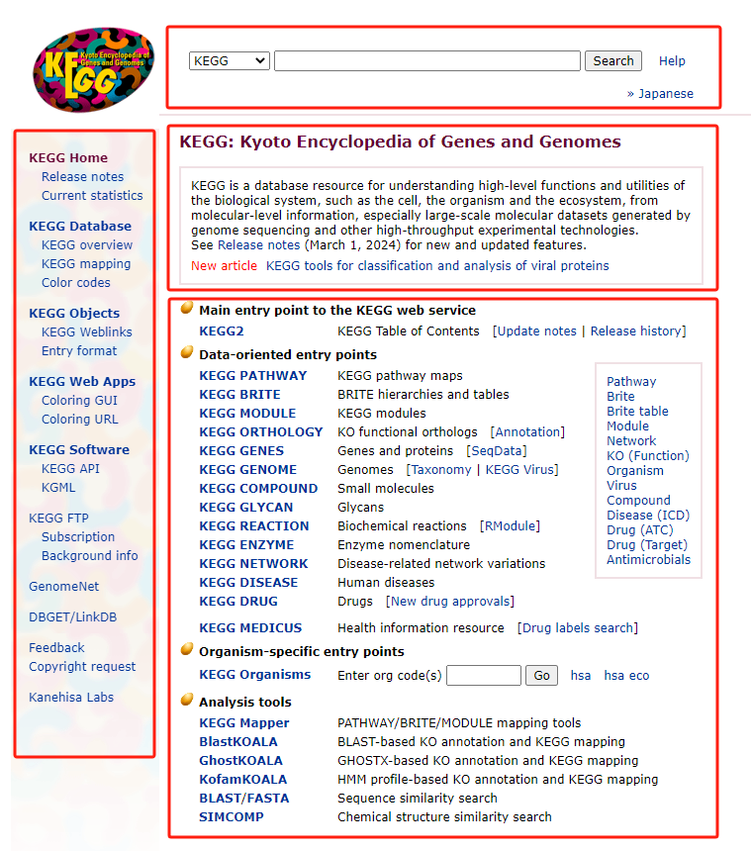

Key Concept
A biological trait usually follows this general pattern:
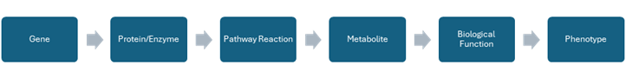
For example:
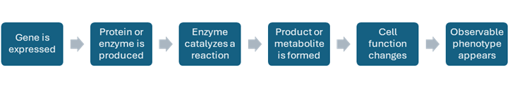

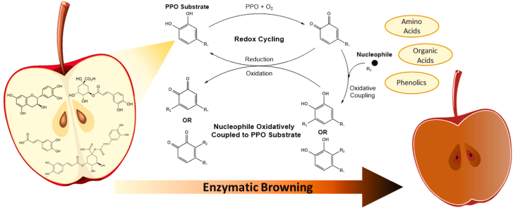

When reading a pathway, ask the following questions:
1. What process is shown?
Is the pathway related to energy, pigment production, stress response, growth, disease, or metabolism?
2. What is the starting molecule?
This is usually the substrate or precursor.
3. Which enzymes are involved?
Enzymes control the conversion of one molecule into another.
4. What product is formed?
The product may directly or indirectly affect the phenotype.
5. What phenotype may result?
The phenotype is the visible or measurable biological outcome.
In pathway analysis, you may be given different types of data.

Data type | What it tells you
Gene expression | Whether a gene is more or less active
Protein abundance | How much protein is present
Enzyme activity | Whether the enzyme is working
Metabolite level | How much substrate or product is present
Phenotype score | The observable biological result
Important reminder
Gene expression does not always equal phenotype.
High gene expression ≠ always high enzyme activity
High enzyme activity ≠ always high product level
High product level ≠ always strong phenotype
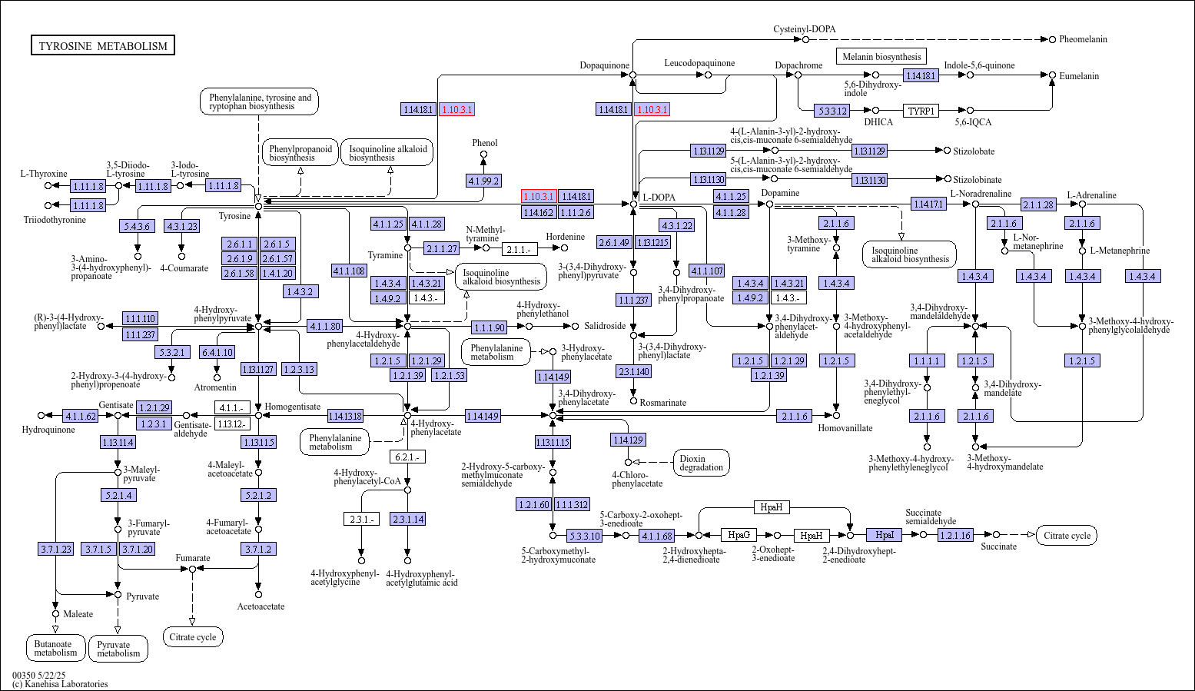
Question 1
A pathway shows:
Substrate X → Enzyme A → Product Y → Phenotype Z
A mutation causes Enzyme A to lose function. What is the most likely result?
A. Product Y increases
B. Product Y decreases
C. Substrate X disappears completely
D. Phenotype Z always increases
Answer: B. Product Y decreases.
Explanation: If Enzyme A loses function, the conversion of Substrate X into Product Y is reduced.

Question 2
Several upstream genes in a pathway are upregulated, but the final product level is low. Which explanation is most likely?
A. The pathway must be fully active.
B. A downstream enzyme may be inhibited or nonfunctional.
C. Gene expression always equals metabolite level.
D. The pathway has no biological meaning.
Answer: B. A downstream enzyme may be inhibited or nonfunctional.
Explanation: Upstream activation does not guarantee final product formation if a later step is blocked.

Question 3
Why is it important to know where a gene is located in a pathway?
Suggested answer: The position of a gene in a pathway helps explain its possible role. An upstream gene may affect substrate supply, while a downstream gene may affect final product formation. Knowing the position helps predict the biological outcome.

Question 4
How can KEGG help explain a biological phenotype?
Suggested answer: KEGG shows how genes, enzymes, and metabolites are connected in pathways. By looking at which parts of the pathway change, we can explain why a phenotype appears, disappears, or changes in intensity.

Scenario
A researcher studies a plant pathway that produces a protective compound during stress.
Simplified pathway
Precursor molecule
↓ Enzyme A
Intermediate molecule
↓ Enzyme B
Protective compound
↓
Stress tolerance

Data table
Plant line | Enzyme A expression | Enzyme B expression | Enzyme A activity | Enzyme B activity | Protective compound | Stress tolerance
Line 1 | Low | Low | Low | Low | Low | Low
Line 2 | High | High | High | High | High | High
Line 3 | High | High | High | Low | Low | Low
Line 4 | High | Low | High | Low | Low | Low

Questions
1. Which plant line is most stress tolerant?
Answer: Line 2.
Explanation: Line 2 has high enzyme expression, high enzyme activity, high protective compound level, and high stress tolerance.

2. Which plant line may have an inactive or inhibited Enzyme B?
Answer: Line 3.
Explanation: Line 3 has high Enzyme B expression but low Enzyme B activity. This suggests that the enzyme may be inhibited or nonfunctional.

3. Which plant line shows low expression of both enzymes?
Answer: Line 1.
Explanation: Line 1 has low expression of both Enzyme A and Enzyme B.

4. Why does Line 3 have low stress tolerance despite high gene expression?
Answer: Enzyme B activity is low, so the protective compound is not produced efficiently.
Explanation: High gene expression alone is not enough. Enzyme activity is needed to produce the protective compound.

5. Which measurement is closest to the final phenotype?
Answer: Protective compound level.
Explanation: The protective compound directly contributes to stress tolerance, so it is more directly related to the phenotype than gene expression alone.

